Mid Term Report
on
AI Data Analyst Agent

Project-I

BACHELOR OF TECHNOLOGY
(Artificial Intelligence and Machine Learning)


SUBMITTED BY:
Name: Pravleen Kaur
Roll No: 2231103
May 2026

Under the Guidance of
Ms. Kawalpreet Kaur
Associate Professor

Department of Artificial Intelligence and Machine Learning
Chandigarh Engineering College
Jhanjeri, Mohali - 140307

INDEX
S.No. | Chapter / Section | Page No.
1. | Chapter 1: Introduction | 3
 | 1.1 Background | 3
 | 1.2 Project Overview | 4
 | 1.3 Motivation | 5
 | 1.4 Objectives of the Project | 6
 | 1.5 Tools Learnt | 7
2. | Chapter 2: System Requirements | 10
 | 2.1 Hardware Requirements | 10
 | 2.2 Software Requirements | 11
 | 2.3 Library Requirements | 12
 | 2.4 API Requirements | 13
3. | Chapter 3: Software Requirement Analysis | 15
 | 3.1 Problem Definition | 15
 | 3.2 Functional Requirements | 16
 | 3.3 Non-Functional Requirements | 18
 | 3.4 Modules and Functionalities | 19
4. | Chapter 4: Software Design | 22
 | 4.1 System Architecture | 22
 | 4.2 Data Flow Diagram | 24
 | 4.3 Use Case Diagram | 25
 | 4.4 Module Design | 26
5. | Chapter 5: Implementation | 28
 | 5.1 Project Structure | 28
 | 5.2 Code Implementation | 29
 | 5.3 Implementation Status | 33
6. | References | 35

Chapter 1
INTRODUCTION

In today's data-driven era, organizations across all industries generate massive amounts of data on a daily basis. The ability to extract meaningful insights from this data has become a critical factor for business success, scientific advancement, and informed decision-making. However, traditional data analysis methods require specialized knowledge of programming languages such as Python, R, or SQL, along with a deep understanding of statistical techniques and data visualization tools. This creates a significant barrier for non-technical users who need to interact with and understand their data but lack the technical expertise to do so effectively [1]. This project aims to bridge this gap by developing an intelligent AI Agent that enables users to perform comprehensive data analysis through natural language queries.

  - Background

The emergence of Large Language Models (LLMs) such as Google Gemini, OpenAI GPT-4, and Meta LLaMA has opened up new possibilities in the field of artificial intelligence. These models demonstrate remarkable capabilities in understanding and generating human language, making them ideal candidates for bridging the gap between complex data analysis tasks and natural language communication [2]. When combined with agent-based architectures, these models can perform autonomous, multi-step reasoning and execute complex analytical workflows without explicit programming from the user.

AI Agents represent a paradigm shift in how we interact with intelligent systems. Unlike traditional chatbots that simply generate text responses, AI Agents can perceive their environment, make decisions, use tools, and take actions to achieve specific goals [3]. In the context of data analysis, an AI Agent can autonomously load datasets, clean data, perform statistical analysis, detect patterns, and generate visualizations — all through simple natural language instructions from the user.

The development of frameworks like LangChain has further accelerated the adoption of AI Agents in real-world applications. LangChain provides abstractions for connecting LLMs with external tools, managing conversational memory, and orchestrating complex chains of operations. This framework supports multiple LLM providers, including Google Gemini, OpenAI, and Anthropic, making it a versatile choice for developing AI Agent applications.

  - Project Overview

The proposed AI-Powered Data Analyst Agent is a web-based application designed to democratize data analysis by making it accessible to users without programming or statistical expertise. The system allows users to upload CSV datasets and interact with their data through a conversational chat interface. By leveraging the reasoning capabilities of Google Gemini and the tool orchestration capabilities of LangChain, the system can autonomously understand user intent, select appropriate analytical methods, and deliver actionable insights.

The system architecture follows a modular design pattern, consisting of separate modules for data ingestion, AI orchestration, statistical analysis, and visualization. This separation of concerns ensures that the system is maintainable, scalable, and easy to extend with additional features in future phases. The user interface is built using Streamlit, providing a clean, intuitive, and responsive experience that works seamlessly across different devices and screen sizes.
Users can ask natural language questions such as "What are the key trends in my sales data?", "Find correlations between revenue and customer age", or "Detect outliers in the price column", and the AI Agent processes these queries, analyzes the relevant data, and provides detailed insights along with supporting information. The system maintains conversation history, enabling context-aware multi-turn interactions where users can build upon previous queries.

The system supports multiple Google Gemini models, ranging from the lightweight gemini-2.5-flash-lite for fast queries to the powerful gemini-2.5-pro for complex analytical reasoning. This flexibility allows users to balance between speed, quality, and cost based on their specific requirements. Additionally, the system implements robust error handling for API quota limits, network issues, and invalid data formats.

The frontend incorporates custom CSS styling and JavaScript interactivity to provide a modern, professional appearance. The chat interface features animated message bubbles, gradient backgrounds, and smooth transitions, creating an engaging user experience. The sidebar provides quick action buttons for common analytical tasks, allowing users to perform standard analyses with a single click.

  - Motivation

The motivation behind this project stems from the increasing demand for data analysis capabilities across all sectors of society, combined with the persistent challenges that prevent non-technical users from accessing these capabilities effectively. Several key factors have driven the development of this project.

Firstly, the data revolution has reached every domain — from small businesses tracking sales to researchers analyzing experimental results, from educators evaluating student performance to social media managers monitoring engagement metrics. Despite this widespread need, the tools available for data analysis remain largely inaccessible to those without technical training. Commercial platforms like Tableau and Power BI offer powerful capabilities but require expensive licenses and substantial training to use effectively.

Secondly, the rapid advancement of Large Language Models has created unprecedented opportunities to redefine human-computer interaction. Models like Google Gemini have demonstrated remarkable abilities in understanding context, reasoning about complex problems, and generating human-like responses. By harnessing these capabilities, it becomes possible to create systems that can understand and respond to natural language queries about data, eliminating the need for users to learn complex query languages or programming syntax.

Thirdly, the emergence of AI Agent architectures represents one of the most significant trends in artificial intelligence as of 2024-2025. The development of autonomous agents capable of using tools, maintaining context, and performing multi-step reasoning is widely regarded as a crucial step toward more general artificial intelligence systems. This project provides hands-on experience with this cutting-edge technology while solving a practical real-world problem.

Finally, this project serves as a comprehensive learning experience that integrates multiple modern technologies and concepts. It combines artificial intelligence, web development, data science, software engineering principles, and user experience design into a cohesive system. The skills and knowledge gained through this project are directly applicable to the rapidly growing field of AI-powered applications, making it valuable both academically and professionally.
The project also aligns with the broader goal of making technology more
accessible and inclusive. By removing the technical barriers that prevent many people from leveraging the power of data analysis, the system contributes to digital democratization and empowers users from diverse backgrounds to make data-driven decisions.

  - Objectives of the Project

The primary objectives of this project are outlined below:

- To develop an AI-powered Data Analyst Agent that can understand and respond to natural language queries about uploaded datasets, enabling users without programming expertise to perform comprehensive data analysis through simple conversational interactions.
- To integrate Google Gemini API as the core Large Language Model for natural language understanding, reasoning, and intelligent response generation, ensuring high-quality analytical outputs that are both accurate and easy to understand.
- To implement modular data analysis tools including data profiling, descriptive statistics computation, correlation analysis, outlier detection, trend analysis, and group-based aggregation using industry-standard libraries such as Pandas and NumPy.
- To design an interactive web-based user interface using the Streamlit framework that provides a seamless user experience for data upload, conversational querying, and result visualization, with custom CSS styling for a modern and professional appearance.
- To enable automated visualization generation using the Plotly library, supporting multiple chart types including bar charts, line charts, scatter plots, histograms, box plots, pie charts, and correlation heatmaps with interactive features.
- To implement a context-aware conversational system that maintains chat history and provides coherent, contextually relevant responses across multiple user interactions, allowing users to build complex analytical conversations naturally.
- To support multiple AI model options allowing users to select from various Google Gemini models based on their specific requirements for processing speed, response quality, and API quota considerations.
- To create a scalable and maintainable system architecture following modular design principles, with separate components for data handling, AI orchestration, visualization, and user interface, enabling easy future enhancements.
- To implement robust error handling and validation mechanisms for handling various edge cases such as invalid file formats, API quota exhaustion, network connectivity issues, and malformed user queries.
- To provide quick action functionality through pre-defined buttons in the sidebar that enable users to perform common analytical tasks such as data summary generation, correlation finding, and outlier detection with a single click.

  - Tools Learnt

During the development of this project, several important tools, technologies, frameworks, and concepts were studied and applied. The comprehensive list of tools learnt is provided below:

    - Programming Languages

- Python 3.12: The primary programming language used for the entire backend development. Advanced Python concepts including object-oriented programming (OOP), decorators, context managers, generators, type hints, and module management were extensively studied and applied.
- HTML5: Used for structuring web content within the Streamlit application, particularly for custom chat interface components and rich text formatting in AI responses.
- CSS3: Employed for custom styling of the Streamlit interface, including gradient backgrounds, animated chat bubbles, hover effects, transitions, and responsive design elements.
- JavaScript (ES6): Used for client-side interactivity such as auto-scrolling chat containers, copy-to-clipboard functionality, and dynamic UI updates.

    - AI and Machine Learning Frameworks

- LangChain Framework: A comprehensive framework for building applications powered by language models. Key concepts learnt include agent architectures, tool integration, prompt engineering, memory management, and chain composition.
- Google Generative AI SDK: The official Python SDK for interacting with Google's Gemini models. Topics covered include API authentication, model selection, prompt construction, response parsing, and rate limit handling.
- Prompt Engineering: Techniques for crafting effective prompts that guide LLM behavior, including system prompts, few-shot learning, chain-of-thought prompting, and context injection.

    - Web Development Frameworks

- Streamlit: A modern Python framework for building interactive web applications. Concepts learnt include reactive components, session state management, custom HTML/CSS injection, file uploads, sidebar navigation, and chat components.

    - Data Processing Libraries

- Pandas: A powerful library for data manipulation and analysis. Topics covered include DataFrame operations, data cleaning, missing value handling, grouping and aggregation, statistical functions, and CSV/Excel file I/O.
- NumPy: The fundamental package for scientific computing in Python. Concepts learnt include array operations, mathematical functions, statistical computations, and linear algebra operations.

    - Visualization Libraries

- Plotly: An interactive graphing library used for creating modern, web-based visualizations. Chart types learnt include bar charts, line charts, scatter plots, histograms, box plots, pie charts, and heatmaps with customizable styling and interactivity.

    - Development Tools

- Visual Studio Code: A modern code editor used for project development. Features explored include integrated terminal, debugging tools, extension management, and Git integration.
- Git: A distributed version control system used for project management. Commands learnt include init, add, commit, push, pull, branch, merge, and clone.
- Virtual Environment (venv): A tool for creating isolated Python environments. Concepts include environment creation, activation, dependency management, and requirements.txt files.
- pip: The Python package installer used for managing project dependencies, including installation, upgrading, and uninstalling packages.

    - Software Engineering Concepts

- Modular Programming: Designing software as a collection of separate modules that can be combined to form a complete system.
- MVC Architecture: Understanding the Model-View-Controller pattern as applied to web applications.
- Error Handling: Implementing try-except blocks, custom exceptions, and graceful error recovery mechanisms.
- Documentation: Writing clear code comments, docstrings, and README files for project documentation.

Chapter 2
SYSTEM REQUIREMENTS

This chapter provides a comprehensive description of the hardware, software, library, and API requirements necessary for the successful development, deployment, and operation of the AI-Powered Data Analyst Agent. These requirements have been carefully analyzed to ensure that the system can run efficiently on standard computing hardware while providing professional-grade functionality.

2.1 Hardware Requirements

The hardware requirements for the proposed system are deliberately kept minimal to ensure broad accessibility. The system has been designed to run efficiently on standard personal computers and laptops commonly used by students, professionals, and small businesses. Table 2.1 lists both the minimum and recommended hardware specifications.

Table 2.1: Hardware Requirements

Component | Minimum Specification | Recommended Specification
Processor | Intel Core i3 (8th Gen) or AMD Ryzen 3 | Intel Core i5/i7 or AMD Ryzen 5/7
RAM | 4 GB | 8 GB or higher
Storage | 2 GB free disk space | 5 GB free SSD space
Display Resolution | 1366 x 768 pixels | 1920 x 1080 pixels (Full HD)
Internet Connection | Broadband (1 Mbps) | Broadband (10 Mbps or higher)
GPU | Not Required | Optional (for future enhancements)
Graphics Card | Integrated graphics sufficient | Dedicated GPU optional

The minimum hardware requirements ensure that the application can run on entry-level systems, while the recommended specifications provide an optimal user experience with faster response times and smoother UI rendering. Since the heavy computational tasks (LLM inference) are performed on Google's cloud servers, local hardware requirements remain modest.
The internet connection is particularly important since the system relies on real-time API calls to Google Gemini. A stable broadband connection ensures consistent performance and reduces latency in AI responses. For users with intermittent internet connectivity, the system implements appropriate error handling and retry mechanisms to handle network failures gracefully.

2.2 Software Requirements

The software requirements encompass the operating system, development tools, runtime environments, and external services required to develop, run, and maintain the AI Data Analyst Agent. Table 2.2 presents the comprehensive software requirements.

Table 2.2: Software Requirements

Software | Specification | Purpose
Operating System | Windows 10/11, Ubuntu 20.04+, macOS 12+ | Base platform for execution
Programming Language | Python 3.12 (3.8 or higher) | Primary development language
Code Editor / IDE | Visual Studio Code (Latest) | Development environment
Web Browser | Google Chrome, Mozilla Firefox, Edge | UI rendering and interaction
Version Control | Git 2.0 or higher | Source code management
Package Manager | pip (Python package installer) | Library installation
Terminal | PowerShell, Bash, or Command Prompt | Command execution
Text Editor | Notepad++ or similar (optional) | Quick file edits

The choice of Python as the primary programming language is justified by its extensive ecosystem of data science libraries, ease of use, and strong community support. Python 3.12 was selected as the development version due to its performance improvements, enhanced type hints, and better error messages compared to earlier versions.

Visual Studio Code was chosen as the primary IDE due to its lightweight nature, extensive plugin ecosystem, integrated terminal, and excellent Python support through extensions. The editor provides features such as syntax highlighting, code completion, debugging, and Git integration that significantly enhance developer productivity.
The system is cross-platform compatible, meaning it can be developed and run on Windows, Linux, or macOS without any modifications. This flexibility ensures that the application can be deployed in diverse environments without compatibility issues. The use of Streamlit further enhances cross-platform compatibility by providing a unified web-based interface that works identically across all operating systems.
For users on Windows systems, PowerShell is the recommended terminal due to its modern features and better handling of Python virtual environments. Linux and macOS users can use the default Bash or Zsh terminals without any modifications to the project setup process.

2.3 Library Requirements

The project relies on a carefully selected set of Python libraries, each chosen for its specific functionality, performance, and compatibility with other components. These libraries are managed through pip and listed in the requirements.txt file for easy installation. Table 2.3 provides a detailed breakdown of all library requirements with their versions and purposes.

Table 2.3: Python Library Requirements

Library | Version | Purpose
langchain | 0.2.16 | Core agent orchestration framework
langchain-community | 0.2.16 | Community integrations and tools
langchain-core | 0.2.40 | Core LangChain abstractions
langchain-google-genai | 1.0.10 | Google Gemini integration
streamlit | 1.28+ | Web application framework
pandas | 2.0+ | Data manipulation and analysis
numpy | 1.24+ | Numerical computing
plotly | 5.18+ | Interactive data visualization
python-dotenv | 1.0+ | Environment variable management
openpyxl | 3.1+ | Excel file reading/writing
google-generativeai | 0.7.2 | Google Generative AI SDK

The version specifications ensure compatibility between libraries and prevent dependency conflicts. The langchain ecosystem libraries are pinned to specific versions because of their rapid development cycle, where breaking changes can occur frequently between versions. Other libraries use minimum version specifiers (e.g., 1.28+) to allow newer versions while ensuring required features are available.

Pandas serves as the workhorse for all data manipulation tasks, providing efficient DataFrame operations that can handle datasets ranging from a few rows to millions of records. NumPy provides the underlying numerical operations that power both Pandas and many statistical computations. The combination of these two libraries forms the foundation of the data analysis capabilities.

Plotly was chosen over alternatives like Matplotlib due to its interactive capabilities, modern aesthetic, and seamless integration with Streamlit. Plotly charts can be embedded directly in the web interface and provide features such as zooming, panning, hovering for details, and exporting to various formats.

The python-dotenv library plays a critical role in security by allowing API keys and other sensitive credentials to be stored in a separate .env file rather than being hardcoded in the source code. This separation enables the source code to be safely shared on platforms like GitHub without exposing private credentials.

2.4 API Requirements

The system relies on external API services to provide its core AI functionality. The primary API requirement is access to Google's Gemini API through Google AI Studio. This section details the API requirements, authentication process, and usage considerations.

2.4.1 Google AI Studio API

The Google AI Studio API provides access to Google's family of Gemini language models. To use this API, users need to:
- Create a Google account (if they don't already have one)
- Visit Google AI Studio at https://aistudio.google.com
- Generate a free API key from the dashboard
- Configure the API key in the application's .env file

Table 2.4: API Configuration Details

Parameter | Specification
API Provider | Google AI Studio
API Endpoint | https://generativelanguage.googleapis.com
Authentication | API Key (Bearer Token)
Free Tier Quota | Varies by model
Rate Limits | Per minute and per day limits
Supported Models | Gemini 2.0/2.5 Flash, Pro, Lite variants

2.4.2 Available Gemini Models

The system supports multiple Gemini models, each optimized for different use cases:
- gemini-2.5-flash-lite: The fastest and most economical option with the highest free tier quota. Ideal for simple queries and quick analysis.
- gemini-2.5-flash: Provides a balance between speed and quality. Suitable for most analytical tasks with moderate complexity.
- gemini-2.5-pro: The most powerful model with advanced reasoning capabilities. Best for complex analytical queries requiring deep understanding.
- gemini-2.0-flash: A reliable workhorse model with good performance across various tasks.

2.4.3 Quota Management
The system implements intelligent quota management to handle Google's free tier limitations. When a user exceeds their quota, the system provides informative error messages and suggests switching to alternative models with available quota. The application also implements automatic retry mechanisms with exponential backoff to handle temporary rate limit errors gracefully.
Users are advised to monitor their API usage through the Google AI Studio dashboard to avoid unexpected quota exhaustion. For production deployments or heavy usage scenarios, users can upgrade to paid API tiers for higher quotas and faster response times.

Chapter 3
SOFTWARE REQUIREMENT ANALYSIS

This chapter presents a detailed analysis of the software requirements for the AI-Powered Data Analyst Agent. It includes the formal problem definition, identification of functional and non-functional requirements, and a comprehensive description of the system modules and their respective functionalities.

3.1 Problem Definition

Data analysis has emerged as one of the most critical activities in modern organizations, yet it remains largely inaccessible to those without specialized technical training. The current landscape of data analysis tools presents several significant challenges that limit their effectiveness for the broader user base.

3.1.1 Technical Barrier

Traditional data analysis requires proficiency in programming languages such as Python, R, or SQL, along with knowledge of statistical libraries like Pandas, NumPy, Scikit-learn, and visualization libraries such as Matplotlib or Seaborn. This creates an exclusion barrier for non-technical professionals — including small business owners, educators, healthcare workers, and researchers from non-computing fields — who need data-driven insights but lack the necessary coding skills.
The learning curve for these tools is steep, often requiring months or years of dedicated study to achieve proficiency. Even basic analytical tasks can require dozens of lines of code, making it impractical for users who only need occasional data analysis capabilities.

3.1.2 Time-Consuming Processes

Even for experienced data analysts, the process of loading, cleaning, exploring, and visualizing data is repetitive and time-consuming. Standard exploratory data analysis (EDA) tasks such as identifying missing values, detecting outliers, computing correlations, and generating appropriate visualizations require manual effort for each new dataset. This repetitive work consumes valuable time that could be spent on higher-value analytical tasks.

3.1.3 Fragmented Tool Ecosystem

Users typically need to switch between multiple tools to complete a comprehensive analysis workflow. They might use Excel or Google Sheets for initial data viewing, Python or R scripts for statistical analysis, separate visualization libraries for chart generation, and word processors for report writing.

This fragmentation results in inefficient workflows, data inconsistencies, and increased likelihood of errors during data transfer between tools.

3.1.4 High Cost of Enterprise Solutions

Enterprise-grade analytics platforms such as Tableau, Power BI, and Qlik Sense require expensive licenses ranging from hundreds to thousands of dollars per user per year. These costs make professional analytical capabilities inaccessible for small businesses, startups, individual researchers, students, and educational institutions in developing regions. While free alternatives exist, they typically lack the features and polish of commercial solutions.

3.1.5 Lack of Intelligent Assistance

Existing tools, whether commercial or open-source, primarily execute commands provided by the user. They do not provide intelligent suggestions, automated insights, or contextual recommendations based on the characteristics of the data being analyzed. Users must know exactly what to look for and how to look for it, which assumes a level of analytical expertise that many users lack.

3.1.6 Proposed Solution

The AI-Powered Data Analyst Agent addresses these challenges by providing a unified, intelligent, and conversational platform that enables users of all technical backgrounds to perform comprehensive data analysis through simple natural language queries. By leveraging the reasoning capabilities of Google Gemini and the tool orchestration capabilities of LangChain, the system can:
- Understand user intent expressed in everyday language
- Automatically select appropriate analytical methods
- Execute the required analyses on the user's data
- Generate clear, actionable insights with explanations
- Maintain conversational context for follow-up queries
- Provide visualizations to support textual insights
This approach significantly reduces the time, cost, and expertise required for effective data analysis, making it accessible to a much broader user base than traditional tools.

3.2 Functional Requirements

Functional requirements define the specific behaviors and functions that the system must perform. These requirements describe what the system should do rather than how it should do it.

3.2.1 Data Management Requirements

- FR-1: The system shall allow users to upload CSV files through a web interface.
- FR-2: The system shall validate uploaded files for proper CSV format.
- FR-3: The system shall display a preview of the loaded data showing the first 10 rows.
- FR-4: The system shall identify and display data types for each column.
- FR-5: The system shall detect and report missing values in the dataset.
- FR-6: The system shall support files up to 200 MB in size.

3.2.2 AI Interaction Requirements

- FR-7: The system shall accept natural language queries from users about their data.
- FR-8: The system shall connect to Google Gemini API for processing queries.
- FR-9: The system shall maintain conversation history across multiple queries.
- FR-10: The system shall provide context-aware responses considering the loaded data.
- FR-11: The system shall allow users to clear chat history when needed.
- FR-12: The system shall support multiple AI model selection.

3.2.3 Analysis Requirements

- FR-13: The system shall compute descriptive statistics on numerical columns.
- FR-14: The system shall calculate correlations between numeric variables.
- FR-15: The system shall detect outliers using statistical methods.
- FR-16: The system shall identify trends in time-series data.
- FR-17: The system shall perform group-based aggregations on categorical data.
- FR-18: The system shall generate automated insights from the dataset.

3.2.4 Visualization Requirements

- FR-19: The system shall generate appropriate charts based on data types.
- FR-20: The system shall support multiple chart types (bar, line, scatter, etc.).
- FR-21: The system shall provide interactive visualizations with zoom and hover.

3.2.5 User Interface Requirements

- FR-22: The system shall provide a sidebar with quick action buttons.
- FR-23: The system shall display chat messages with distinct user/AI styling.
- FR-24: The system shall show loading indicators during AI processing.
- FR-25: The system shall display error messages clearly when issues occur.

3.3 Non-Functional Requirements

Non-functional requirements define the quality attributes and constraints of the system. These requirements specify how the system should perform rather than what it should do.

3.3.1 Performance Requirements

- NFR-1: The system shall load CSV files of up to 100 MB within 10 seconds.
- NFR-2: The system shall provide AI responses within 30 seconds under normal conditions.
- NFR-3: The user interface shall respond to user actions within 1 second.
- NFR-4: The system shall handle datasets with up to 1 million rows efficiently.
- NFR-5: The system shall support concurrent multi-user access (in multi-user deployment).

3.3.2 Usability Requirements

- NFR-6: The system shall be usable by individuals without programming knowledge.
- NFR-7: The user interface shall be intuitive and self-explanatory.
- NFR-8: The system shall provide helpful error messages with suggested solutions.
- NFR-9: The interface shall be accessible on standard web browsers.
- NFR-10: The system shall provide tooltips and helper text for complex features.

3.3.3 Reliability Requirements

- NFR-11: The system shall maintain 99% uptime under normal operating conditions.
- NFR-12: The system shall handle API failures gracefully without crashing.
- NFR-13: The system shall implement retry mechanisms for transient errors.
- NFR-14: The system shall preserve user data integrity throughout the session.

3.3.4 Security Requirements

- NFR-15: API keys shall be stored securely in environment variables.
- NFR-16: User-uploaded data shall not be stored persistently on the server.
- NFR-17: The system shall sanitize user inputs to prevent injection attacks.
- NFR-18: All API communications shall use HTTPS encryption.

3.3.5 Maintainability Requirements

- NFR-19: The codebase shall follow PEP 8 Python coding standards.
- NFR-20: All major functions shall have comprehensive docstrings.
- NFR-21: The system shall use a modular architecture for easy maintenance.
- NFR-22: Configuration shall be externalized in separate files.

3.3.6 Compatibility Requirements

- NFR-23: The system shall work on Windows 10/11, Ubuntu 20.04+, and macOS 12+.
- NFR-24: The web interface shall be compatible with Chrome, Firefox, and Edge.
- NFR-25: The system shall support Python 3.8 and higher versions.

3.4 Modules and Functionalities

The proposed system is logically divided into five primary modules, each handling specific responsibilities. This modular design ensures separation of concerns, makes the codebase maintainable, and allows independent development and testing of each module.

3.4.1 Data Ingestion Module

The Data Ingestion Module is responsible for handling all aspects of data input into the system. Its primary functionalities include:
- File Upload Handling: Accepts CSV files through the Streamlit file uploader component, with size validation and format checking.
- File Format Validation: Ensures that uploaded files conform to valid CSV format, checking for proper delimiters, header rows, and encoding.
- Data Loading: Uses Pandas to read CSV files into DataFrame objects for further processing, handling various edge cases such as different encodings and delimiters.
- Initial Profiling: Generates basic profiling information including the number of rows, columns, data types, and missing value counts.
- Data Preview: Provides a tabular preview of the first few rows of the loaded data for user verification.
- Error Handling: Manages various error conditions such as corrupted files, unsupported formats, or empty datasets with clear user feedback.

3.4.2 AI Agent Orchestrator Module

The AI Agent Orchestrator serves as the central intelligence of the system, coordinating between the user interface, language model, and analytical tools. Its key functionalities are:
- Query Processing: Receives natural language queries from the user and prepares them for processing by the language model.
- Context Construction: Builds context-aware prompts that include relevant dataset information, statistical summaries, and conversation history.
- LLM Communication: Manages all interactions with the Google Gemini API, including authentication, request formatting, and response parsing.
- Memory Management: Maintains conversation history to enable multi-turn interactions and context-aware responses.
- Response Formatting: Processes raw LLM responses to extract relevant information and format it appropriately for display.
- Error Recovery: Implements robust error handling for API failures, rate limits, and network issues.
- Model Selection: Allows dynamic switching between different Gemini models based on user preferences and query complexity.

3.4.3 Analysis Tools Module

The Analysis Tools Module implements the actual statistical and analytical computations required for data analysis. Its functionalities include:

- Descriptive Statistics: Computes measures of central tendency (mean, median, mode), dispersion (variance, standard deviation), and distribution (skewness, kurtosis) for numerical columns.
- Correlation Analysis: Calculates Pearson, Spearman, and Kendall correlation coefficients between pairs of numerical variables, identifying strong relationships in the data.
- Outlier Detection: Implements multiple outlier detection methods including the Interquartile Range (IQR) method and Z-score method to identify anomalous data points.
- Trend Analysis: Detects trends and patterns in time-series data, including linear trends, seasonality, and changepoints.
- Group Analysis: Performs aggregations and statistical computations grouped by categorical variables, enabling segment-wise analysis.
- Missing Value Analysis: Identifies patterns of missing data and provides recommendations for handling them appropriately.

3.4.4 Visualization Module

The Visualization Module is responsible for generating interactive charts and graphs based on the data and user requirements. Its functionalities include:

- Chart Type Selection: Automatically selects appropriate chart types based on data characteristics and analytical goals.
- Bar Charts: Generates vertical and horizontal bar charts for categorical comparisons.
- Line Charts: Creates line charts for time-series data and trend visualization.
- Scatter Plots: Produces scatter plots for examining relationships between numerical variables.
- Histograms: Generates histograms for visualizing data distributions.
- Box Plots: Creates box plots for comparing distributions across categories and identifying outliers visually.
- Heatmaps: Produces correlation heatmaps for visualizing relationships between multiple variables simultaneously.
- Pie Charts: Generates pie charts for visualizing parts of a whole.
- Customization: Allows customization of chart titles, axis labels, colors, and other visual elements.

3.4.5 User Interface Module

The User Interface Module provides the web-based front-end through which users interact with the system. Its functionalities include:

- Layout Management: Organizes the interface into logical sections including header, sidebar, and main content area.
- File Upload Interface: Provides a drag-and-drop file uploader with progress indication.
- Chat Interface: Implements a conversational chat interface with distinct styling for user and AI messages.
- Settings Panel: Offers configuration options including API key input, model selection, and display preferences.
- Quick Actions: Provides pre-defined buttons for common analytical tasks, allowing single-click access to frequent operations.
- Status Indicators: Shows loading spinners, success messages, and error notifications to keep users informed about system status.
- Responsive Design: Ensures the interface works well across different screen sizes and devices.
- Custom Styling: Implements custom CSS for a modern, professional appearance with gradient backgrounds, animations, and smooth transitions.

The interaction between these five modules creates a cohesive system where the user's natural language queries are seamlessly transformed into analytical insights. The Data Ingestion Module loads the data, the AI Agent Orchestrator interprets the user's intent and coordinates the response, the Analysis Tools Module performs the actual computations, the Visualization Module generates supporting graphics, and the User Interface Module presents everything to the user in an accessible format.

Chapter 4
SOFTWARE DESIGN

This chapter presents the comprehensive design of the AI-Powered Data Analyst Agent, including the overall system architecture, data flow diagrams, use case diagrams, and detailed module-level designs. These design artifacts provide a blueprint for the implementation phase and serve as documentation for future maintenance and enhancements.

4.1 System Architecture

The proposed system follows a layered architecture pattern, which is widely recognized as a best practice for building maintainable and scalable software applications. The architecture consists of four primary layers, each with specific responsibilities and well-defined interfaces with adjacent layers. This separation of concerns ensures that changes in one layer do not adversely affect other layers, making the system flexible and easy to maintain.

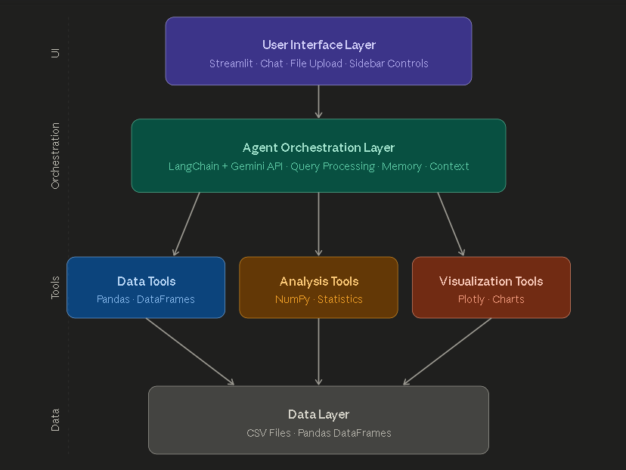
Figure 4.1: System Architecture of AI Data Analyst Agent

4.1.1 User Interface Layer

The User Interface Layer is the topmost layer of the architecture and serves as the primary interaction point between the user and the system. Built using the Streamlit framework, this layer provides a modern, web-based interface that runs in any standard web browser. The layer is responsible for rendering all visual components, capturing user inputs, and displaying system outputs.

Key components of this layer include the file upload widget for data ingestion, the conversational chat interface for natural language interactions, the sidebar containing settings and quick action buttons, and the main display area for showing data previews and visualizations. Custom CSS and JavaScript code is integrated to provide enhanced styling and interactivity beyond what Streamlit offers by default.

4.1.2 Agent Orchestration Layer

The Agent Orchestration Layer serves as the brain of the system. It receives user queries from the UI layer, processes them using the Google Gemini language model, coordinates with various tools to gather necessary information, and returns formatted responses. This layer is implemented using the LangChain framework, which provides abstractions for managing language models, tools, and conversational memory.

The layer maintains a conversation history that enables context-aware multi-turn interactions. When a user asks a follow-up question, the system can reference previous exchanges to provide relevant responses. The layer also constructs comprehensive prompts that include dataset context, ensuring the language model has access to all necessary information for accurate analysis.

4.1.3 Tool Layer

The Tool Layer contains specialized modules for performing specific tasks. The Data Tools module, built on Pandas, handles data loading and basic manipulation. The Analysis Tools module, leveraging NumPy and Pandas, performs statistical computations. The Visualization Tools module, powered by Plotly, generates interactive charts and graphs. These tools are independent of each other and can be invoked by the orchestration layer as needed.

4.1.4 Data Layer

The Data Layer is the foundation of the architecture. It manages the actual data using Pandas DataFrames, which provide efficient in-memory storage and manipulation capabilities. Data is loaded from CSV files uploaded by users and remains in memory throughout the user session. For privacy and security, no user data is persisted to disk on the server.

4.2 Data Flow Diagram

The Data Flow Diagram (DFD) illustrates how data moves through the system from initial user input to final output. It provides a clear visualization of the system's processing pipeline and helps in understanding the interactions between various components.

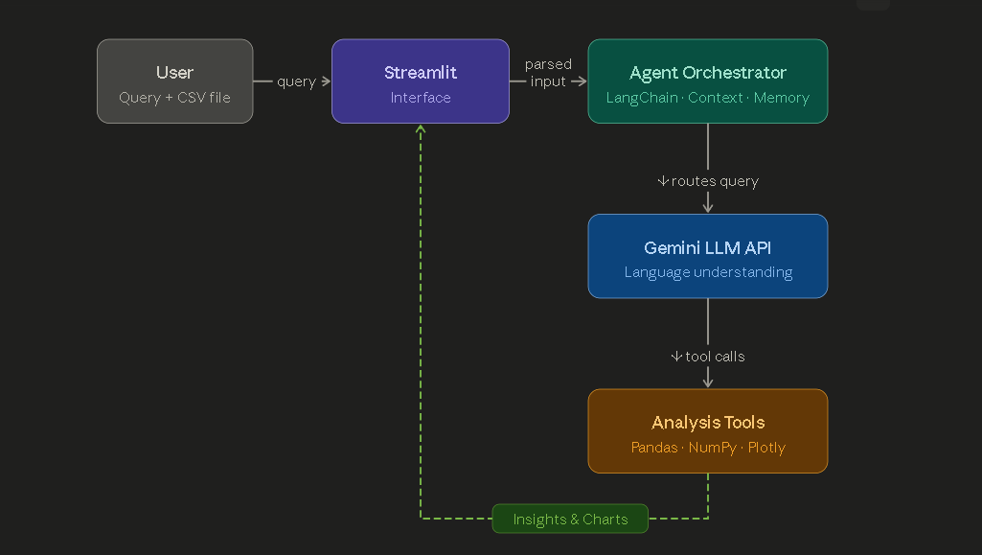 Figure 4.2: Data Flow Diagram of the System

The data flow begins when the user uploads a CSV file through the Streamlit interface. The interface validates the file and passes it to the Agent Orchestrator, which loads the data into a Pandas DataFrame. The dataset profile (column names, types, sample values) is then prepared for use as context.

When the user submits a natural language query, it flows from the interface to the Agent Orchestrator. The Orchestrator constructs a comprehensive prompt that includes the user's query, the dataset context, and any relevant conversation history. This prompt is sent to the Google Gemini API for processing.

The Gemini API analyzes the query and generates an intelligent response. If the response requires additional computations, the Orchestrator coordinates with the Analysis Tools to perform statistical calculations or with the Visualization Tools to generate charts. The results are then formatted and returned through the interface to the user.

This flow enables a seamless conversational experience where users can ask questions, receive insights, and follow up with related queries naturally. The system handles all the complexity of data manipulation and AI interaction transparently in the background.

4.3 Use Case Diagram

The use case diagram identifies the various ways users can interact with the system and the functionality available to them. Figure 4.3 presents the use case diagram showing the primary actor (User) and the various use cases supported by the system.

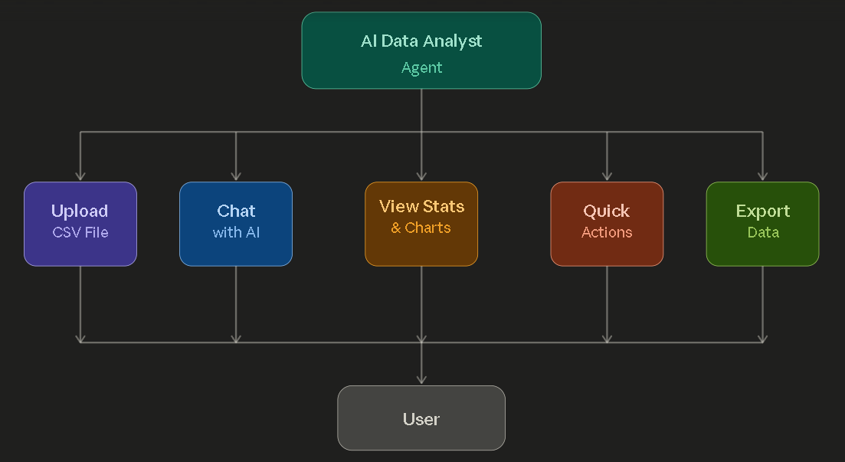Figure 4.3: Use Case Diagram

The use cases supported by the system include:

UC-1: Upload CSV File
The user uploads a CSV file containing data they want to analyze. The system validates and loads the file, providing immediate feedback about the dataset.

UC-2: Chat with AI
The user engages in natural language conversation with the AI agent, asking questions about the data and receiving intelligent responses with insights and recommendations.

UC-3: View Statistics and Charts
The user views statistical summaries and interactive visualizations generated by the system based on their data and queries.

UC-4: Use Quick Actions
The user clicks pre-defined action buttons to perform common analytical tasks without typing queries, speeding up the analysis workflow.

UC-5: Export Data
The user exports data, charts, or analysis results in various formats for external use or sharing.

UC-6: Configure Settings
The user configures system settings such as API key, AI model selection, and display preferences through the sidebar.

4.4 Module Design

The module design provides detailed specifications for each module of the system, including their inputs, outputs, processing logic, and interfaces with other modules. Table 4.1 summarizes the design of each module.

Table 4.1: Module Design Summary

Module | Input | Processing | Output
Data Ingestion | CSV File (User Upload) | Validation, Parsing, Loading | Pandas DataFrame
Agent Orchestrator | User Query + Data Context | LLM Prompt Construction, API Call | AI Response
Analysis Tools | DataFrame + Parameters | Statistical Computations | Numerical Results
Visualization Tools | DataFrame + Chart Type | Chart Generation | Plotly Figure Object
User Interface | User Actions | Event Handling, State Management | Updated UI Components

4.4.1 Data Ingestion Module Interface

Python
class DataTools:
def load_csv_direct(file_path: str, name: str) -> str:
"""Loads CSV file and returns status message"""

def get_data_info(name: str) -> dict:
"""Returns dataset profile information"""

def validate_csv(file_path: str) -> bool:
"""Validates CSV file format"""
4.4.2 Agent Orchestrator Interface
Python
class DataAnalystAgent:
def __init__(api_key: str, model: str):
"""Initializes the agent with API key and model"""

def chat(user_input: str) -> dict:
"""Processes user query and returns AI response"""

def process_file(file_path: str) -> str:
"""Processes uploaded file"""

def clear_history():
"""Clears conversation history"""

The interfaces define clear contracts between modules, allowing each module to be developed and tested independently. This modular approach also facilitates future enhancements, as new features can be added to individual modules without affecting others.

Chapter 5
IMPLEMENTATION

This chapter discusses the actual implementation of the AI-Powered Data Analyst Agent, including the project structure, key code components, and the current implementation status. It provides detailed code snippets that demonstrate how the various design elements are translated into working code.

5.1 Project Structure

The project follows a modular file structure that promotes code organization and maintainability. The structure separates different concerns into distinct directories and files, making it easy for developers to navigate the codebase. Figure 5.1 shows the complete folder structure of the project.
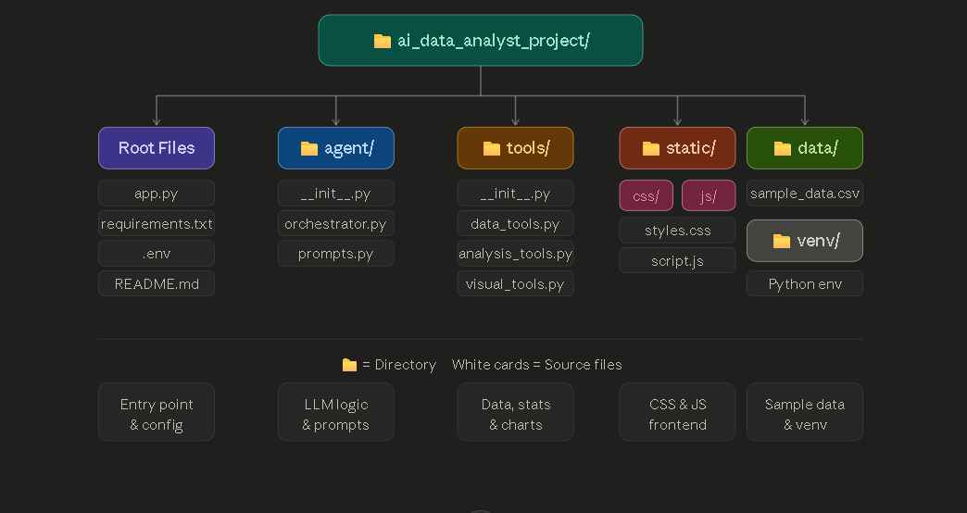Figure 5.1: Project Folder Structure

The app.py file serves as the entry point of the application and contains the Streamlit UI code. The agent/ directory contains the AI orchestration logic, while the tools/ directory holds the various analytical and visualization tools. Static assets like CSS and JavaScript files are organized in the static/ directory, providing clean separation between Python code and frontend assets.

5.2 Code Implementation

This section presents key code snippets from the implementation, demonstrating how various features are realized. The code follows Python best practices including PEP 8 styling, comprehensive docstrings, and proper error handling.

5.2.1 Agent Orchestrator Implementation

The Agent Orchestrator is the core component that coordinates all AI interactions. The following code shows its initialization:
Python
class DataAnalystAgent:
"""AI Data Analyst Agent - Simple & Reliable"""

def __init__(self, api_key=None, model="gemini-2.5-flash-lite"):
# Initialize tools
self.data_tools = DataTools()
self.analysis_tools = AnalysisTools()

# Initialize LLM
self.llm = ChatGoogleGenerativeAI(
model=model,
google_api_key=api_key or os.getenv("GOOGLE_API_KEY"),
temperature=0.7,
convert_system_message_to_human=True
)

# Chat history for context
self.chat_history = []

5.2.2 Chat Method with Data Context

The chat method intelligently injects dataset context into prompts, ensuring the AI has relevant information for accurate analysis:
Python
def chat(self, user_input: str) -> Dict[str, Any]:
"""Process user input and return response."""
try:
# Get data context
data_context = self._get_data_context()

# Build comprehensive prompt
full_prompt = f"""You are an expert AI Data Analyst.

Dataset Information:
{data_context}

User Question: {user_input}

Provide comprehensive analysis with insights."""

# Get response from Gemini
response = self.llm.invoke(full_prompt)

# Save to history
self.chat_history.append({
"role": "user",
"content": user_input
})
self.chat_history.append({
"role": "assistant",
"content": response.content
})

return {"success": True, "output": response.content}
except Exception as e:
return {"success": False, "output": f"Error: {str(e)}"}

5.2.3 Data Loading Function

The data loading function handles CSV ingestion with proper validation and feedback:
Python
def load_csv_direct(self, file_path: str, name: str = "data") -> str:
"""Load a CSV file into the analysis pipeline."""
try:
df = pd.read_csv(file_path)
_dataframes[name] = df
return (f"Loaded {name} with {len(df)} rows and "
f"{len(df.columns)} columns. "
f"Columns: {list(df.columns)}")
except Exception as e:
return f"Error loading CSV: {str(e)}"

5.2.4 Data Context Extraction

The system intelligently extracts dataset context to provide to the AI:
Python
def _get_data_context(self) -> str:
"""Get current data context for the AI"""
if "uploaded_data" not in _dataframes:
return "No data loaded yet."

df = _dataframes["uploaded_data"]

context = f"""
DATASET INFO:
- Rows: {len(df)}
- Columns: {len(df.columns)}
- Column Details:
"""

for col in df.columns:
dtype = df[col].dtype
nulls = df[col].isnull().sum()
context += f" • {col} ({dtype}) - {nulls} nulls\n"

# Add sample data
context += f"\nFIRST 5 ROWS:\n{df.head().to_string()}\n"

# Add statistics
numeric_cols = df.select_dtypes(include=[np.number]).columns
if len(numeric_cols) > 0:
context += (f"\nSTATISTICS:\n"
f"{df[numeric_cols].describe().round(2).to_string()}\n")

return context

5.2.5 Streamlit Main Application

The main application sets up the user interface with sidebar configuration:
Python
def main():
initialize_session_state()

# Load custom CSS and JS
st.markdown(load_css(), unsafe_allow_html=True)
st.markdown(load_js(), unsafe_allow_html=True)

# Header
st.markdown('<h1 class="main-header">AI Data Analyst Agent</h1>',
unsafe_allow_html=True)

with st.sidebar:
api_key = st.text_input("Google AI API Key", type="password")
model = st.selectbox("Select Model",
["gemini-2.5-flash-lite",
"gemini-2.5-flash",
"gemini-2.5-pro"])

if st.button("Initialize Agent"):
st.session_state.agent = DataAnalystAgent(
api_key=api_key,
model=model
)

5.2.6 Quick Actions Implementation

The quick actions feature allows users to perform common tasks with single clicks:
Python
def run_quick_action(query):
"""Helper function to run quick action queries"""
if not st.session_state.agent:
st.error("Initialize agent first!")
return
if not st.session_state.data_loaded:
st.error("Upload data first!")
return

# Add user message to history
st.session_state.chat_history.append({
"role": "user",
"content": query,
"time": datetime.now().strftime("%H:%M")
})

# Get AI response
with st.spinner("Analyzing..."):
response = st.session_state.agent.chat(query)
st.session_state.chat_history.append({
"role": "assistant",
"content": response["output"]
})

5.2.7 Custom CSS Styling

The custom CSS provides modern visual design:
CSS
.main-header {
font-size: 3rem;
font-weight: 800;
background: linear-gradient(120deg, #00d4ff, #ff00ff);
-webkit-background-clip: text;
-webkit-text-fill-color: transparent;
text-align: center;
}

.user-bubble {
background: linear-gradient(135deg, #667eea, #764ba2);
color: white;
padding: 12px 18px;
border-radius: 20px 20px 5px 20px;
box-shadow: 0 4px 15px rgba(102, 126, 234, 0.4);
}

.ai-bubble {
background: linear-gradient(135deg, #00d4ff, #00ff88);
color: white;
padding: 12px 18px;
border-radius: 20px 20px 20px 5px;
box-shadow: 0 4px 15px rgba(0, 212, 255, 0.4);
}

5.3 Implementation Status

The current implementation status of the project is summarized in Table 5.1, which provides a comprehensive view of completed, in-progress, and planned features.

Table 5.1: Current Implementation Status

Module / Feature | Status | Description
Project Setup | Completed | Virtual environment, dependencies installed
Google Gemini Integration | Completed | API connection working with multiple models
LangChain Integration | Completed | Agent framework integrated successfully
CSV File Upload | Completed | File upload and validation working
Data Profiling | Completed | Auto-detection of types, nulls, stats
Chat Interface | Completed | Conversational AI fully functional
Custom UI Styling | Completed | Modern CSS-based interface implemented
Quick Actions | Completed | Pre-defined queries working
Model Selection | Completed | Multiple Gemini models supported
Statistical Analysis | Completed | Stats, correlations, outliers working
Conversation Memory | Completed | Multi-turn context maintained
Error Handling | Completed | Robust error management implemented
Data Preview | Completed | Sample data display working
API Key Management | Completed | Secure .env-based configuration
Export to PDF | Pending | Planned for final submission
Multi-file Support | Pending | Planned for final submission
Advanced Visualizations | Partial | Basic charts done, advanced pending
Voice Input | Future Scope | Planned for next version
Multi-language Support | Future Scope | Planned for next version

The implementation has progressed successfully through the planned phases. The system is currently functional and capable of performing comprehensive data analysis tasks through natural language interaction. All core features required for the basic operation of the system have been completed and tested.The remaining features, marked as "Pending" in the status table, will be implemented in the next phase before the final project submission. These features

primarily focus on enhancing the user experience and adding advanced capabilities such as report generation and support for multiple data files.

The "Future Scope" features represent potential enhancements that could be added in subsequent versions of the project, beyond the scope of this academic submission. These include voice-based input for hands-free interaction and multi-language support to make the system accessible to non-English speakers.The successful completion of these implementation milestones demonstrates the feasibility of the proposed approach and validates the design decisions made during the analysis and design phases. The modular architecture has proven effective in enabling rapid development and easy debugging throughout the implementation process.

REFERENCES

[1] Yao, S., Zhao, J., Yu, D., Du, N., Shafran, I., Narasimhan, K. and Cao, Y., 2023. "ReAct: Synergizing Reasoning and Acting in Language Models", Proceedings of the International Conference on Learning Representations (ICLR), Kigali, Rwanda, pp. 1-25.

[2] Wang, L., Ma, C., Feng, X., Zhang, Z., Yang, H., Zhang, J., Chen, Z., Tang, J. and Wen, J., 2024. "A Survey on Large Language Model based Autonomous Agents", Frontiers of Computer Science, Vol. 18, No. 6, pp. 1-26.

[3] Xi, Z., Chen, W., Guo, X., He, W., Ding, Y., Hong, B., Zhang, M., Wang, J. and Gui, T., 2023. "The Rise and Potential of Large Language Model Based Agents: A Survey", arXiv preprint arXiv:2309.07864.

[4] Luo, Y., Tang, N., Li, G., Tang, J., Chai, C. and Qin, X., 2022. "Natural Language to Visualization by Neural Machine Translation", IEEE Transactions on Visualization and Computer Graphics, Vol. 28, No. 1, pp. 217-226.

[5] Dibia, V., 2023. "LIDA: A Tool for Automatic Generation of Grammar-Agnostic Visualizations and Infographics using Large Language Models", Proceedings of the 61st Annual Meeting of the Association for Computational Linguistics (ACL), Toronto, Canada, pp. 113-126.

[6] Chase, H., 2023. "LangChain: Building Applications with LLMs through Composability", LangChain Documentation, Available at: https://docs.langchain.com (Accessed: June 2025).

[7] Google, 2024. "Gemini API Documentation", Google AI for Developers, Available at: https://ai.google.dev/docs (Accessed: June 2025).

[8] Streamlit Inc., 2024. "Streamlit Documentation: A Faster Way to Build and Share Data Apps", Available at: https://docs.streamlit.io (Accessed: June 2025).

[9] McKinney, W., 2022. "Python for Data Analysis: Data Wrangling with Pandas, NumPy, and Jupyter", O'Reilly Media, Sebastopol, California, 3rd Edition, pp. 1-550.

[10] Plotly Technologies Inc., 2024. "Plotly Python Graphing Library", Available at: https://plotly.com/python/

